Object Avoidance Robot Using Arduino Nano

Name: Md. Akib Jahan
Department: Electrical and Electronic Engineering
Institution: University of Asia Pacific
Semester: 4th
Year: 2nd

Abstract:
This project Is present the design and implementation of an object avoidance robot with using Arduino Nano. The major sensor that I use for the object detection is Ultrasonic sensor. For this robot detect distance of the object and find a long distance to make its path.

Importance:
Object avoidance robot main focus to make automation. In real life we can see many accidents in roads due to sleepiness of driver in highway. From this concept we can reduce the number of accident in roads. Like when the car gets out of control or when a driver sleep the car can hit another car, truck, objects, rocks etc. If we put this system on cars or any vehicle when even chance to make an accident the vehicle stops automatically.

Block Diagram:
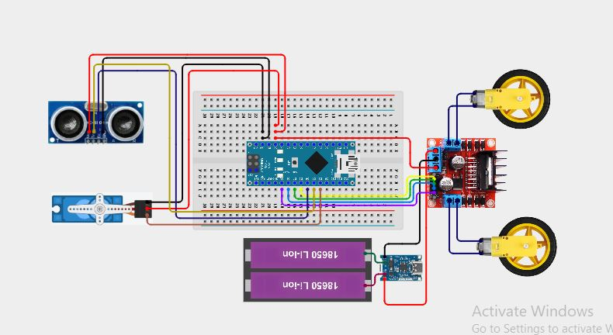

Hardware Description:
Arduino Nano
Ultrasonic Sensor (HC-SR04)
Servo motor (For left-right Ultrasonic sensor)
Motor Driver (L298N)
DC Gear Motors
Charging module
Battery
Chassis & Wheels
Software Description:
- Arduino IDE
- C/C++ language
- Sensor data reading
- Distance calculation
- Decision making
Images of Robot:
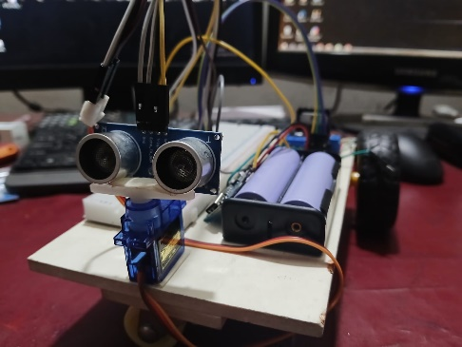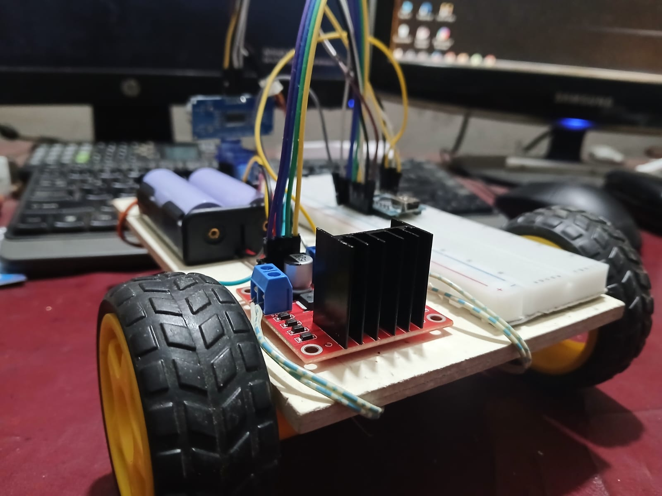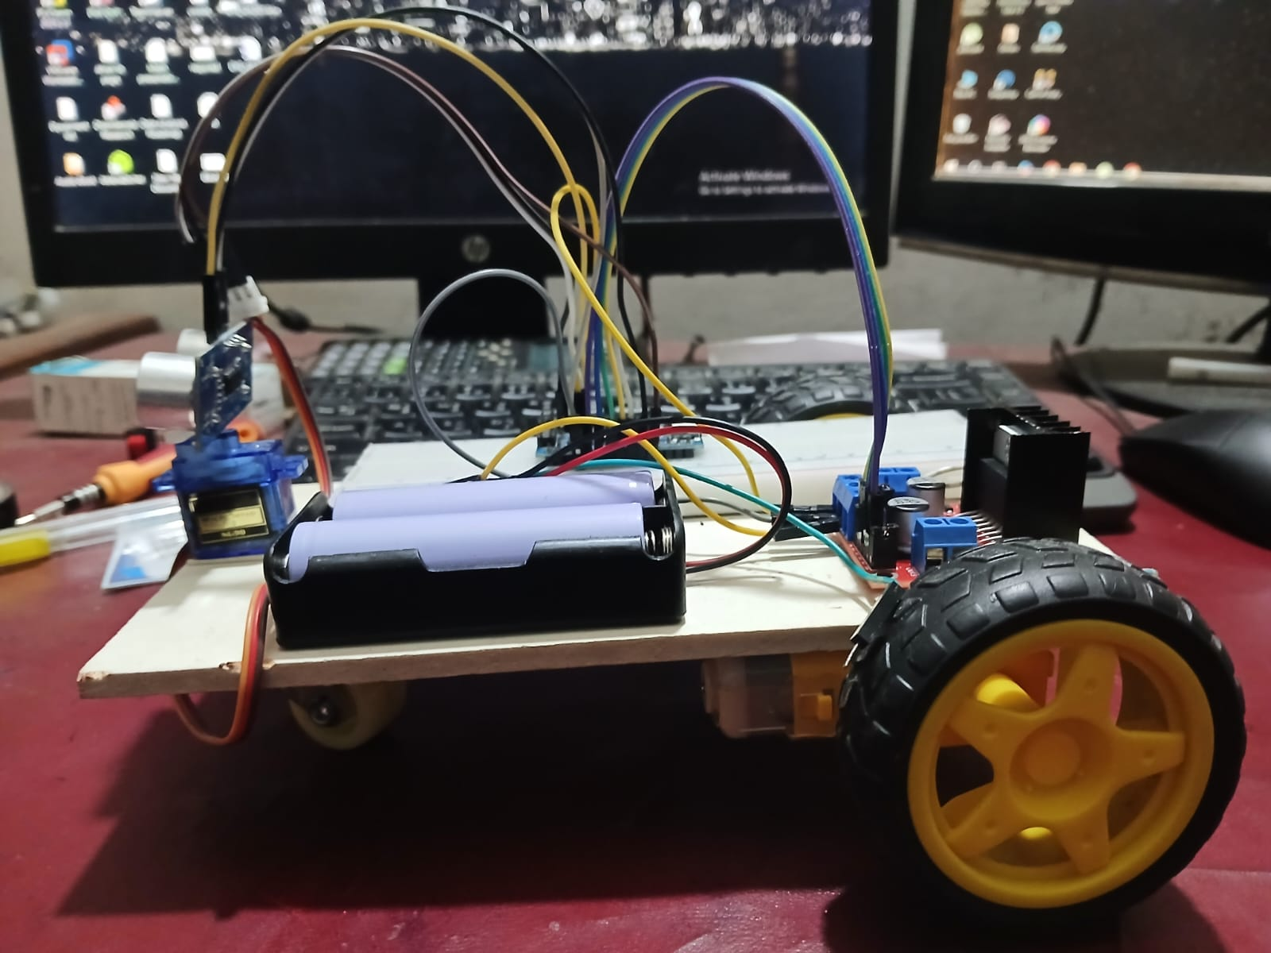
Codes:
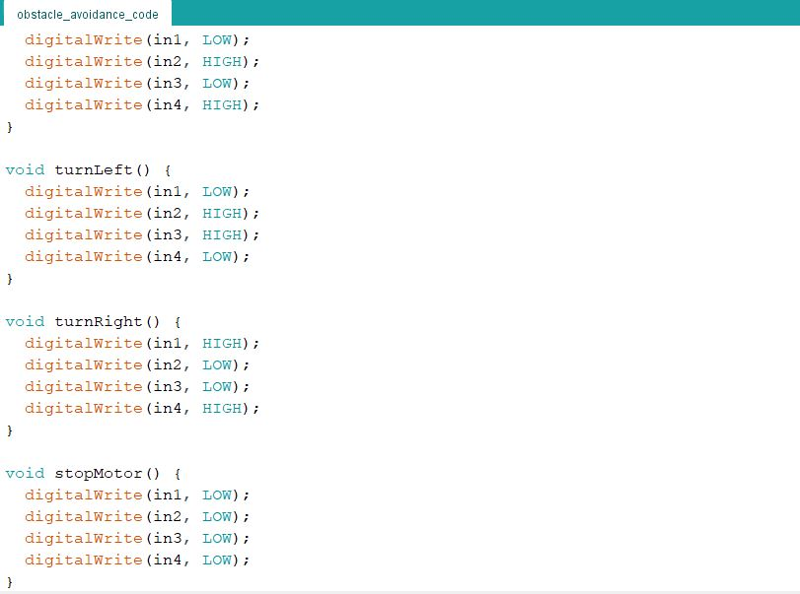
Note: Codes all available in folder Project Code

